# OOP Coursework 1

## Vytautas Krasauskas|3520467|21.11.2017

### Part 1

I created max and subtract classes. They both extend AbstractArrayProcessor. If an array containing same values is passed to max, it will identify the first one as having the largest value. UML diagram below:

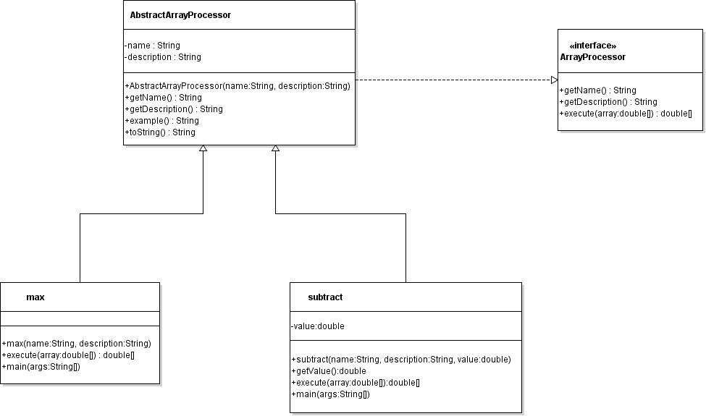

### Part 2

I failed to understand the way we are supposed to write code as the provided UML diagram does not make any sense to me. We are given a very strict way of coding it and there is only one “correct” way. I failed to guess what the methods are supposed to do based solely on their name. Having a setImage() method in every class does not make sense to me. Making openImage(), chooseImageFile(), loadImage() and setImage() call each other in a loop is pointlessly confusing. Maybe if it was a bigger project and those methods actually did something I could have understood them. As it stands now, it is not clear to be what they are supposed to do.

### Part 3

I have not attempted to do part 3 as it depends on part 2.